Project Design Phase-II

Technology Stack (Architecture & Stack)
Project Title | DarshanEase: A Smart Temple Darshan Booking System Using MERN Stack
Team ID | ALITS-CSD-2026-DarshanEase
Team Members | Salapala Tharun Kumar Reddy (Team Leader); A. Goutham; M. Siva Prasad; M. Akhila; K. Hemalatha
College | Anantha Lakshmi Institute of Technology and Sciences (ALITS)
Academic Year | 2026

Technical Architecture
DarshanEase follows a three-tier MERN architecture: a React.js single-page frontend, an Express.js/Node.js REST API backend, and a MongoDB document database, connected via Mongoose. See the accompanying Solution Architecture diagram for the full component view.
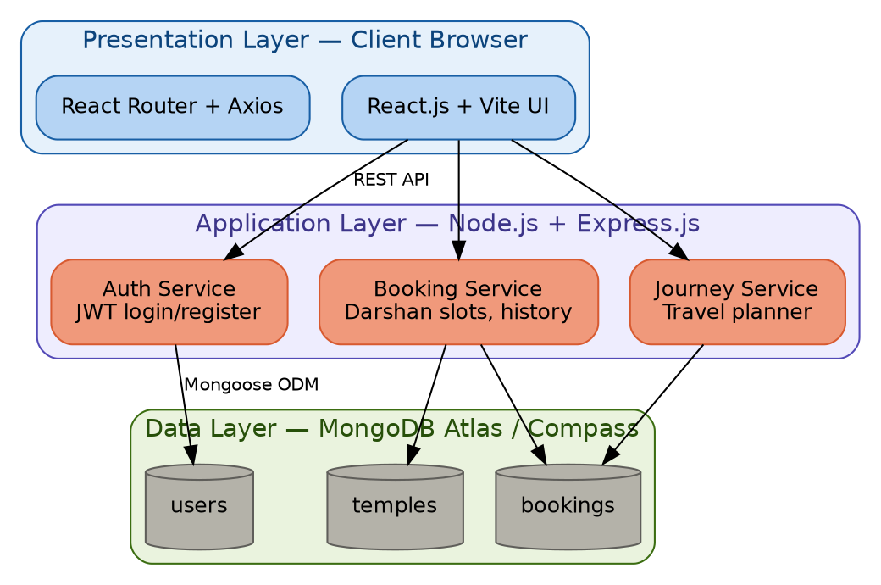
Figure: MERN three-tier technology stack

Table 1: Components & Technologies
S.No | Component | Description | Technology
1 | User Interface | Web UI for devotees and admins to browse, book, and manage darshan slots | React.js, HTML5, CSS3, JavaScript, Vite
2 | Client-side routing & state | Navigation between pages and API communication | React Router DOM, Axios, React Icons
3 | Application Logic - Auth | Registration, login, and session management | Node.js, Express.js, JWT, bcrypt
4 | Application Logic - Booking | Darshan slot booking, confirmation, and history | Node.js, Express.js, Mongoose
5 | Application Logic - Journey | Bus/train/flight journey planning | Node.js, Express.js
6 | Database | Persistent storage of users, temples, bookings, and notifications | MongoDB, MongoDB Compass
7 | Version control & tooling | Source control and local development | Git, GitHub, Visual Studio Code, npm

Table 2: Application Characteristics
S.No | Characteristics | Description | Technology
1 | Open-source frameworks | Frameworks used across the stack | React.js, Express.js, Node.js (open-source)
2 | Security implementations | Access control and data protection | Password hashing (bcrypt), JWT-based authentication, HTTPS
3 | Scalable architecture | Three-tier separation of concerns allows independent scaling | Stateless Express API, MongoDB Atlas horizontal scaling
4 | Availability | Keeping the app reachable with minimal downtime | Cloud-hosted Node.js server, MongoDB Atlas managed clusters
5 | Performance | Fast page loads and API responses | Indexed MongoDB queries, Vite build optimization, lazy loading

